**AI on PC Reference Implementation: How to Build a People Counter Solution**

**Introduction**

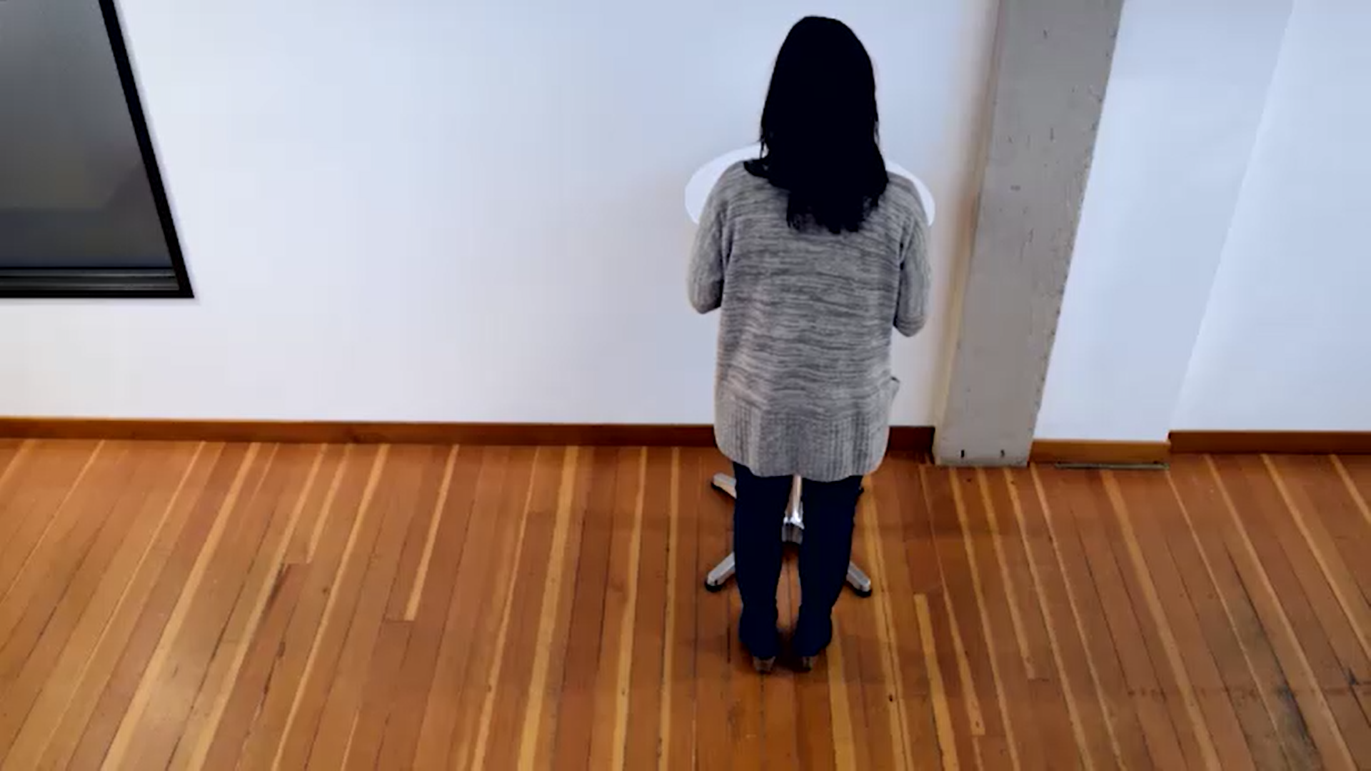 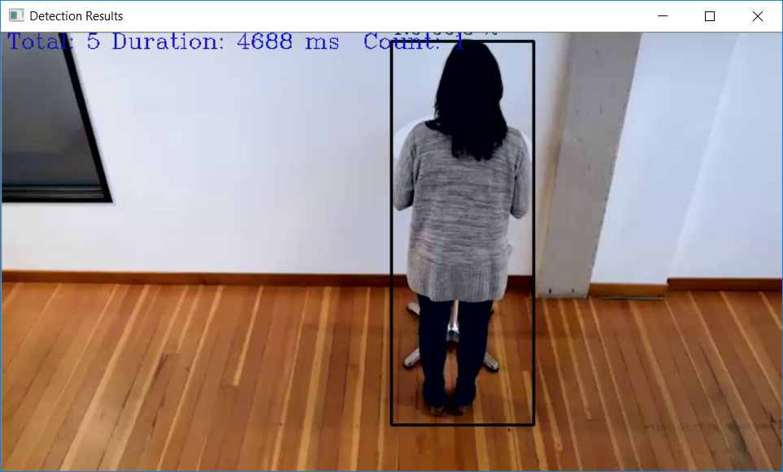

An application capable of counting the number of people in a given input video frame. This solution can be used as a people traffic monitor in retail stores. This data can be utilized by the store owners to optimize staffing, analyzing the store sections bringing in maximum traffic, identify hours that experience maximum traffic etc.

## **What it does**

This application is one of a series of AI on PC reference implementations aimed at instructing users on how to develop a working solution for a particular problem. It demonstrates how to create a people counter solution using Intel® hardware and software tools. This solution monitors -

1. The number of people in a frame at a given time.
2. The total duration for which a set of people/person counted stay in the frame.
3. The cumulative count of people seen so far in the input video.

## **How it Works**

The model uses the Inference Engine included in OpenVINO™. A trained neural network detects people within a defined area by displaying a red bounding box over them. It displays the time for which a person was in the frame by calculating the time duration between the entry and exit point of the person. It displays the cumulative count of people seen so far by incrementing the count every time a new person is identified.

**Running the application**

**Step 1. Launch Visual Studio**

To launch Visual Studio, type Visual Studio 2017 in windows explorer and click on the Visual Studio 2017 option

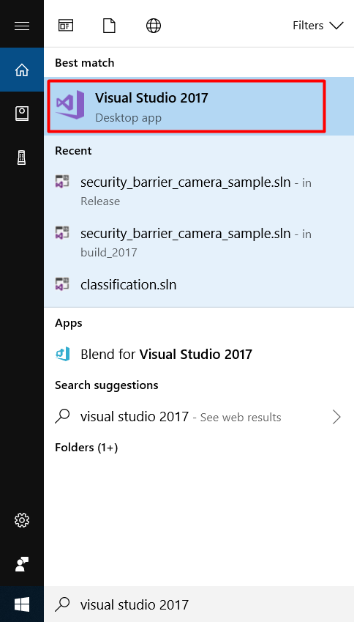

**Step 2. Create a new python project using the existing code in Visual Studio**

1. Choose **File > New > Project …** to create a new project

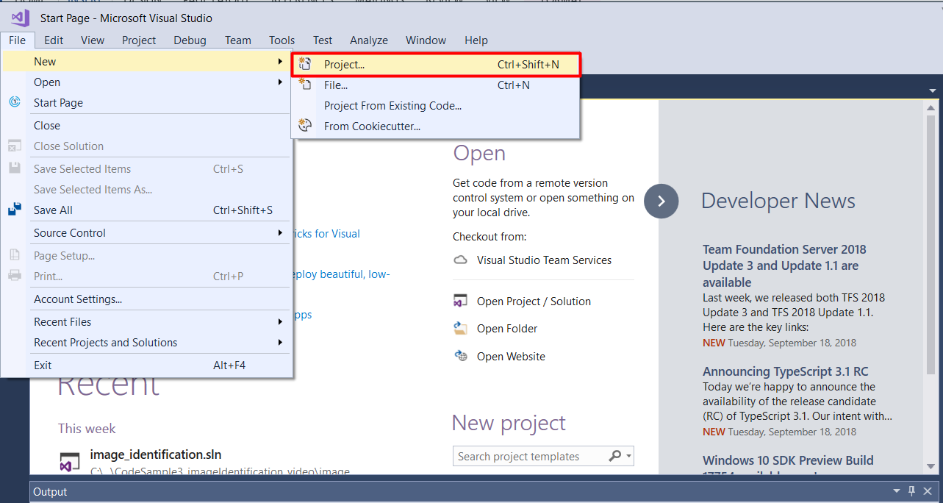

1. You will see a prompt for New Project. Select **Installed > Python > From Existing Python code** from the prompt

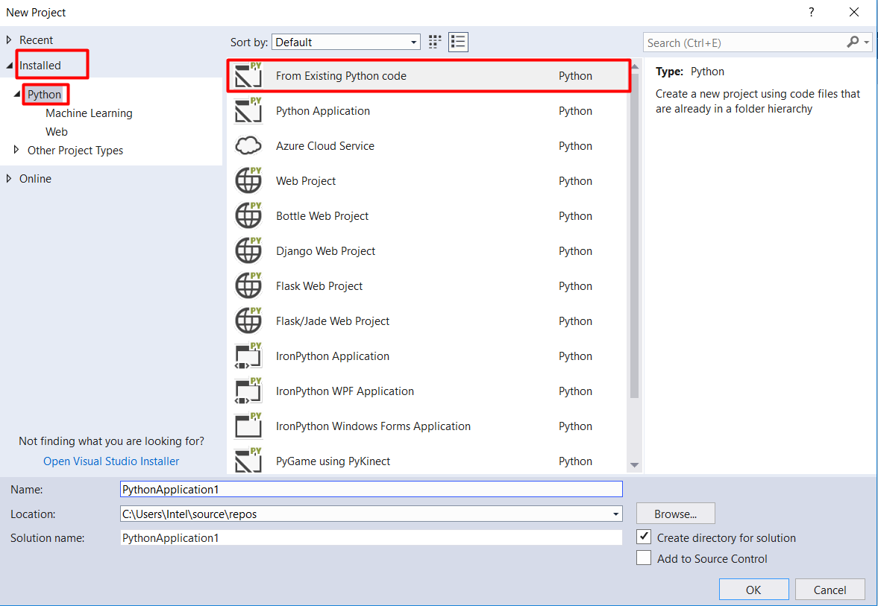

1. Modify the project ‘Name’ and ‘Solution name’ to **people_counter** and click ‘Browse’ button to modify the ‘Location’

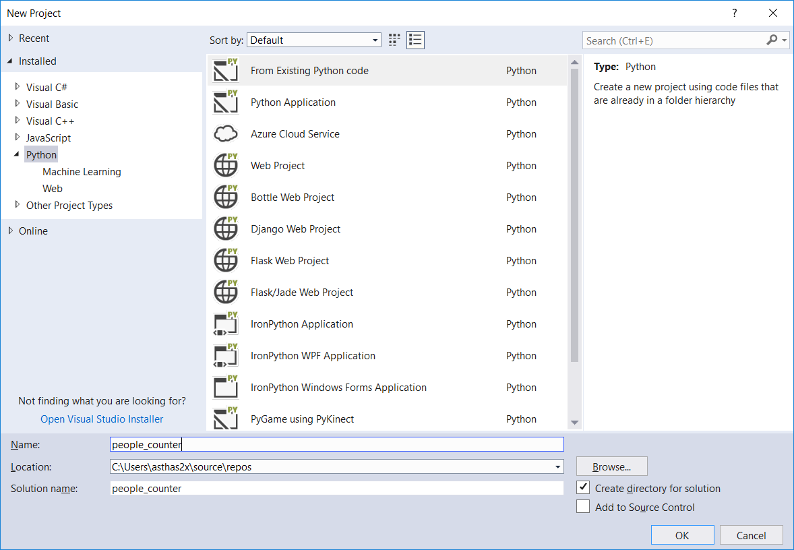

1. Navigate to ‘C:/Intel/AI_on_PC /python_tutorials/Tutorial1_PeopleCounter/people_counter’, select the people_counter folder and click ‘Select Folder’

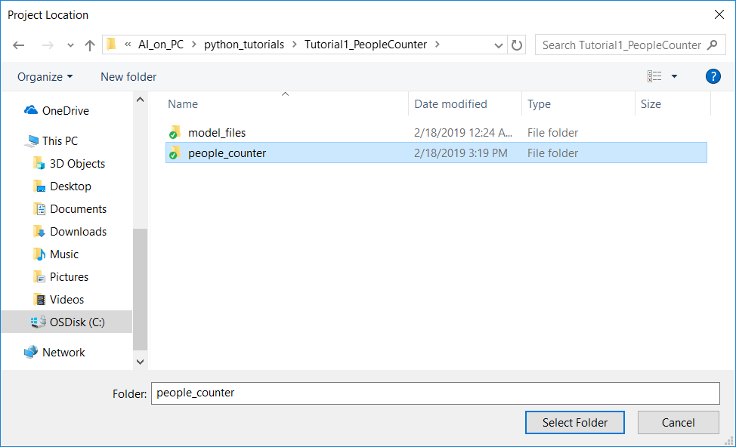

You will see that the location value will now be changed to the people_counter folder

1. Click OK to complete creating the new python project

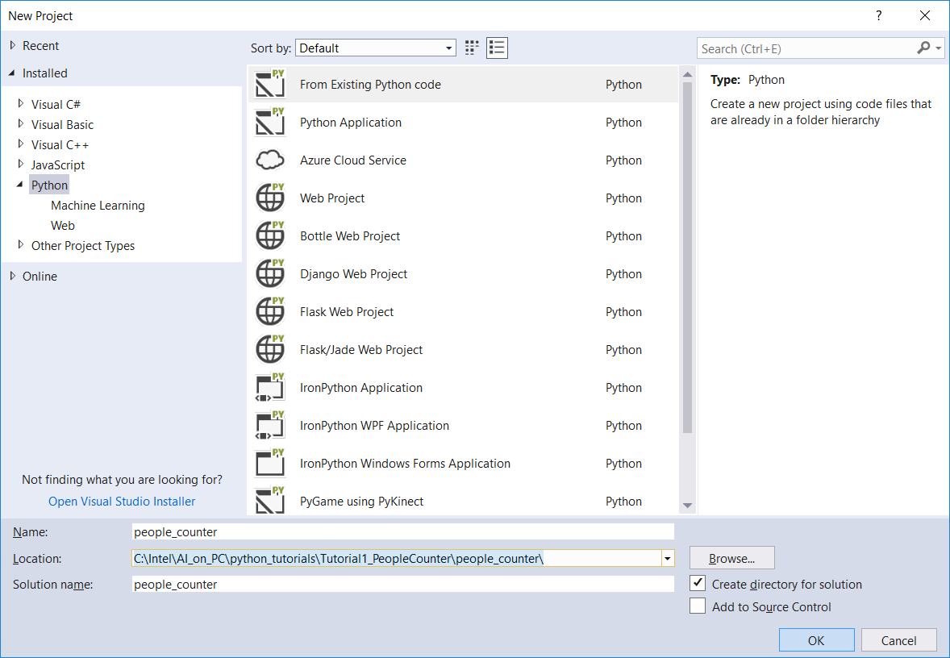

1. After the ‘New Project’ prompt closes, you will see another prompt, ‘Create New Project from Existing Python Code’. The ‘people_counter’ folder contains the python code to be used and will be pre-populated in this prompt. Click Next to select the python file that will be used for the project.

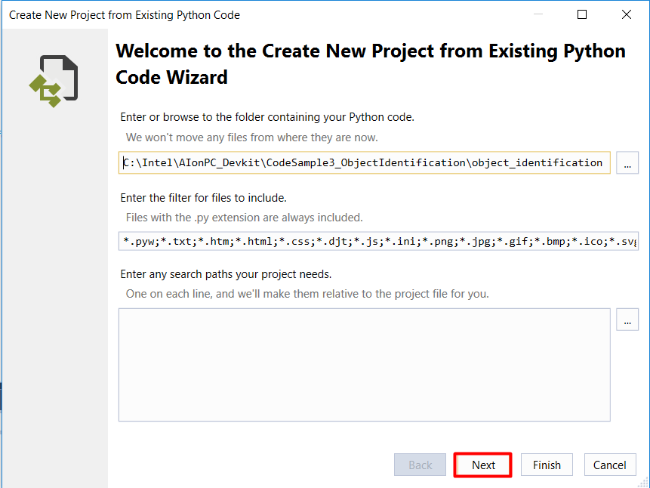

1. Select the ‘people_counter.py’ file and click ‘Next’

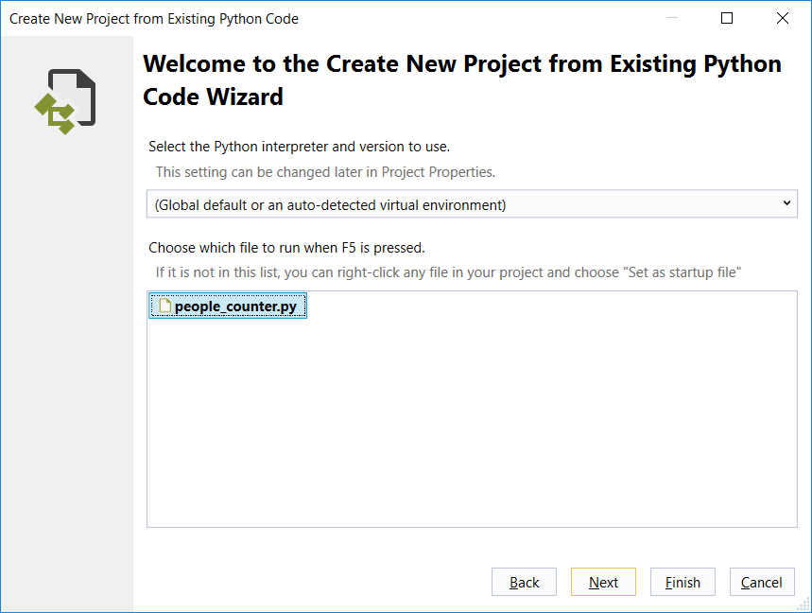

1. Click ‘Finish’ to complete the project creation with the existing python code.

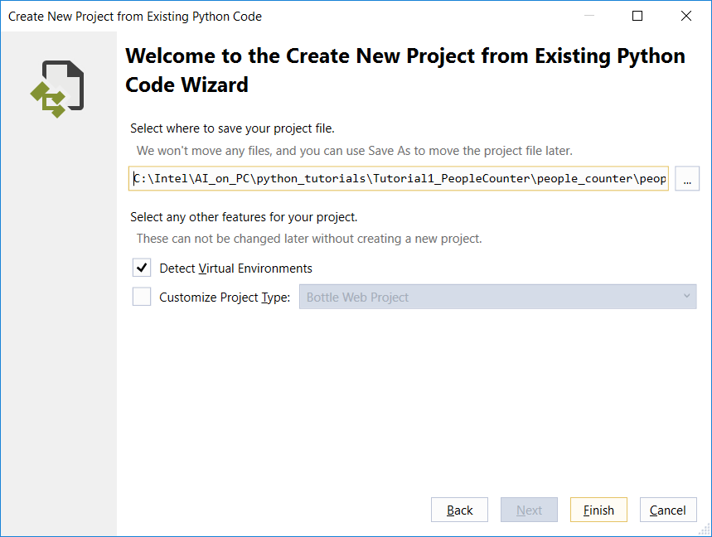

1. The people_counter project will load into the Solution Explorer in Visual Studio

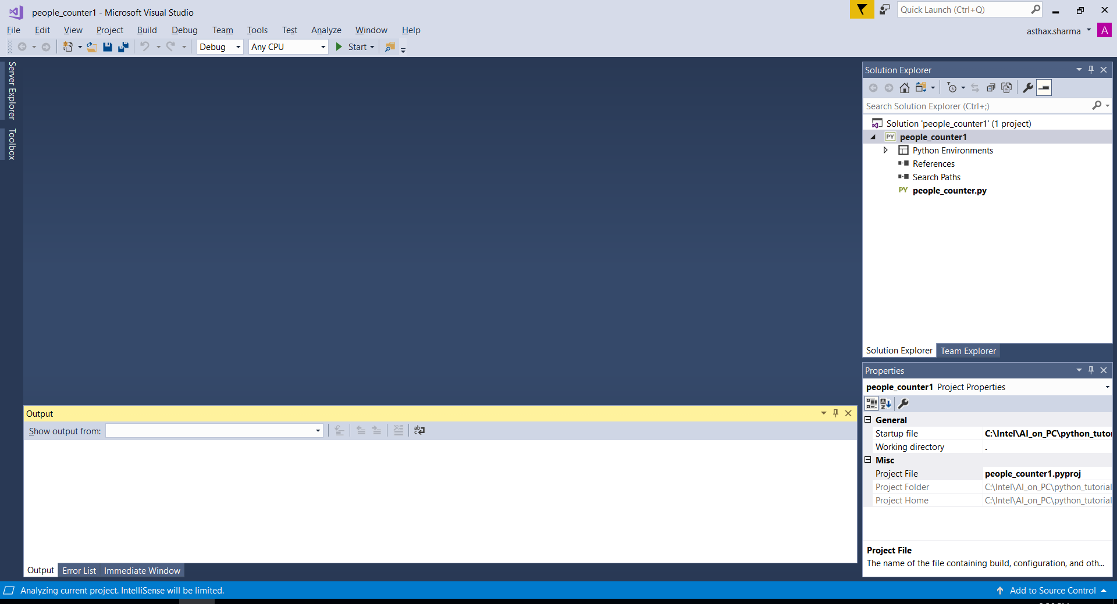

**Step 3. Modify the python file to reflect your python path**

1. Double click the people_counter.py file from the Solution Explorer
2. Modify the <version_number> to reflect the OpenVINO version on your system in the following line of your python code with the version of OpenVINO –

*sys.path.append("C:\Intel\computer_vision_sdk_<version_number>\python\python3.6")*

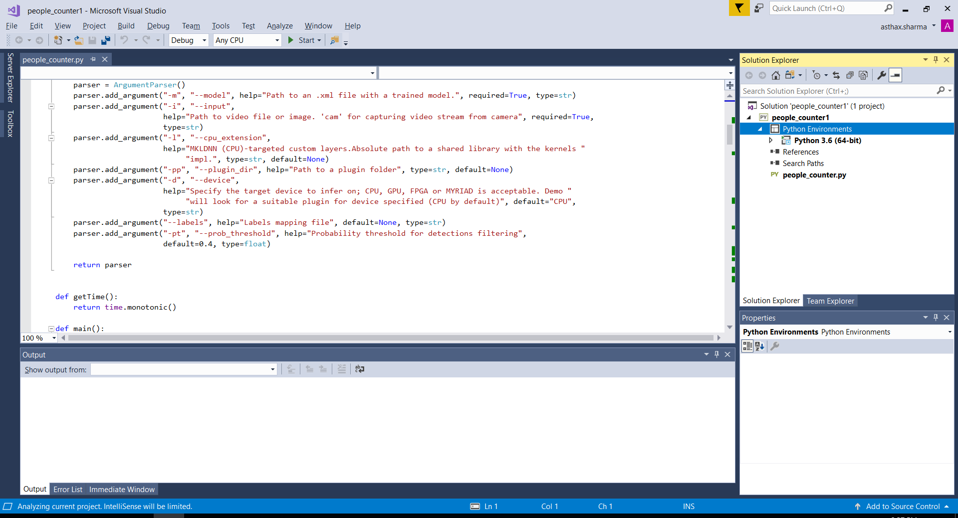

1. Press Ctrl + S from the keyboard to save the changes to the code



**Step 4. Setting up Movidius**

1. Plugin the Movidius Stick into a USB port on your laptop
2. Verify that your laptop has detected the Movidius Stick
   1. Launch Device Manager from the windows explorer

To launch it, type Device Manager in windows explorer and click on the Device Manager option

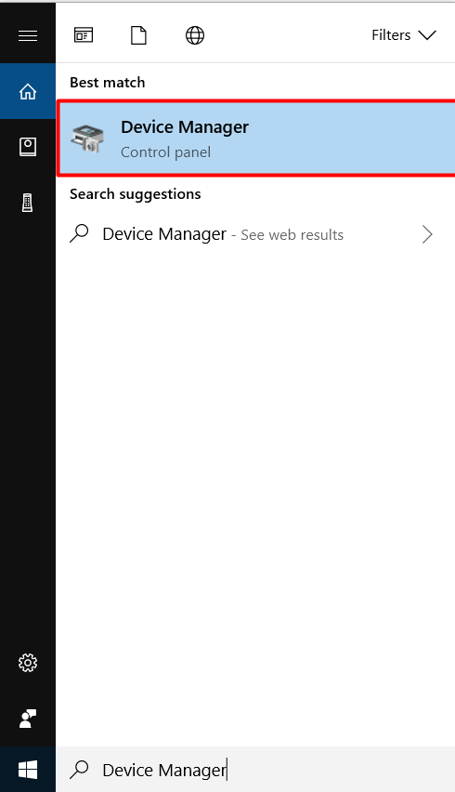

* 1. On the Device Manager screen verify if the option for “Universal Serial Bus devices” is present. If yes, expand the option by clicking the arrow present at its left

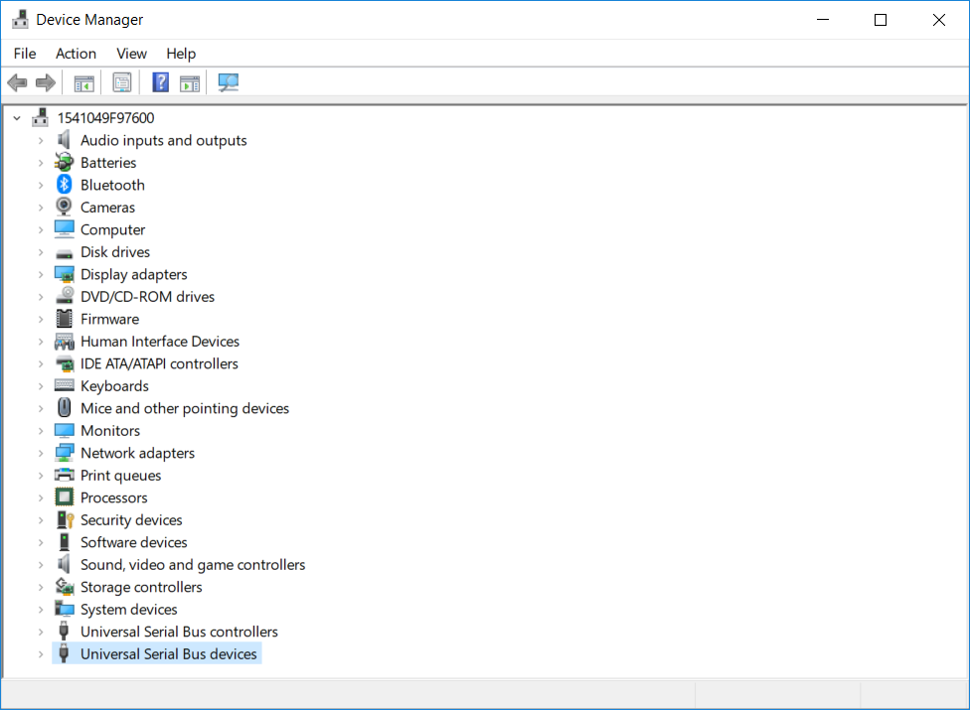

* 1. Verify the option for Movidius MA2X5X in the expanded list

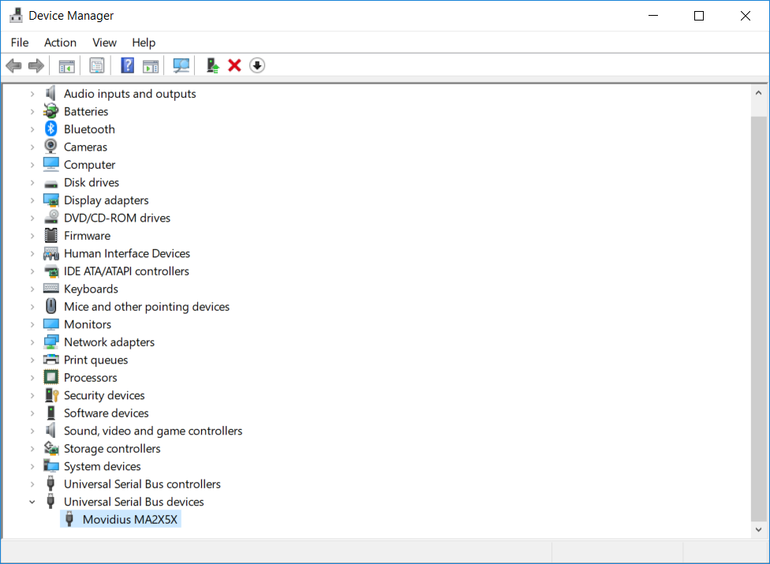

Now that you have made sure that the device is plugged in such that it is getting identified by the system, move back to Visual Studio and continue running the executable.

**Step 4. Run the solution**

1. Right click the people_counter project from the Solution Explorer and click Properties

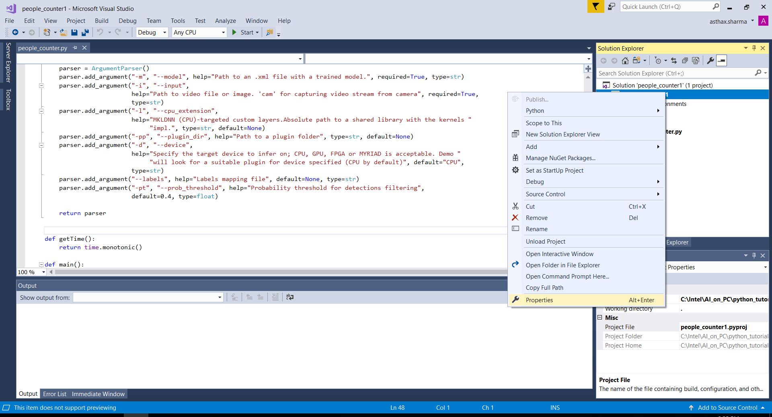

1. The ‘General’ properties for the project opens

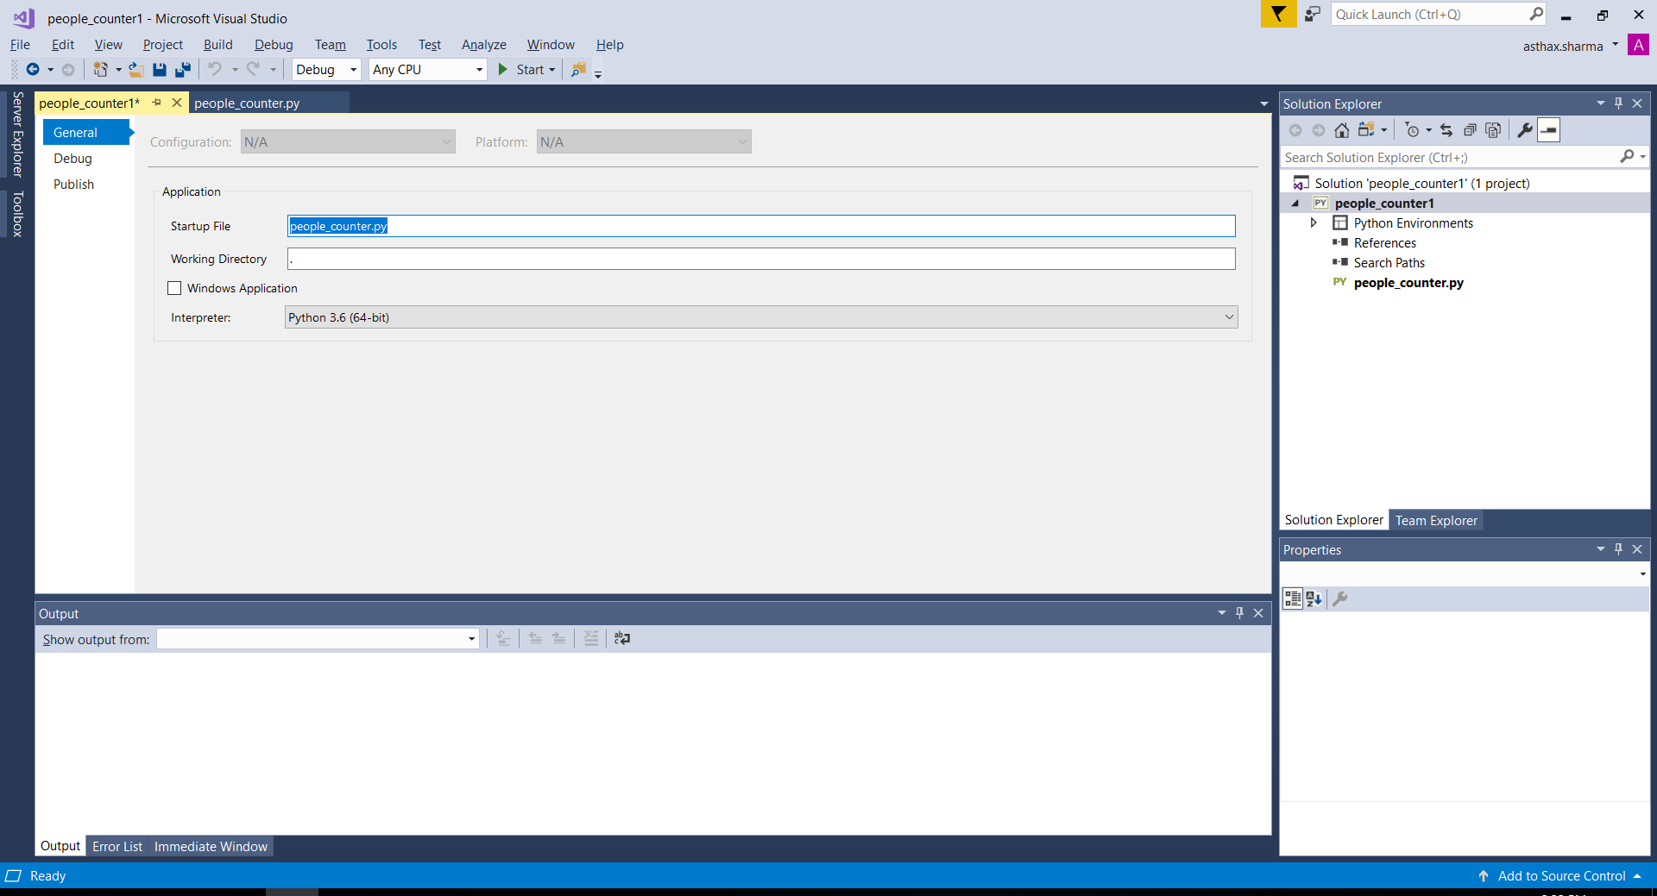

1. Click the ‘Debug’ tab

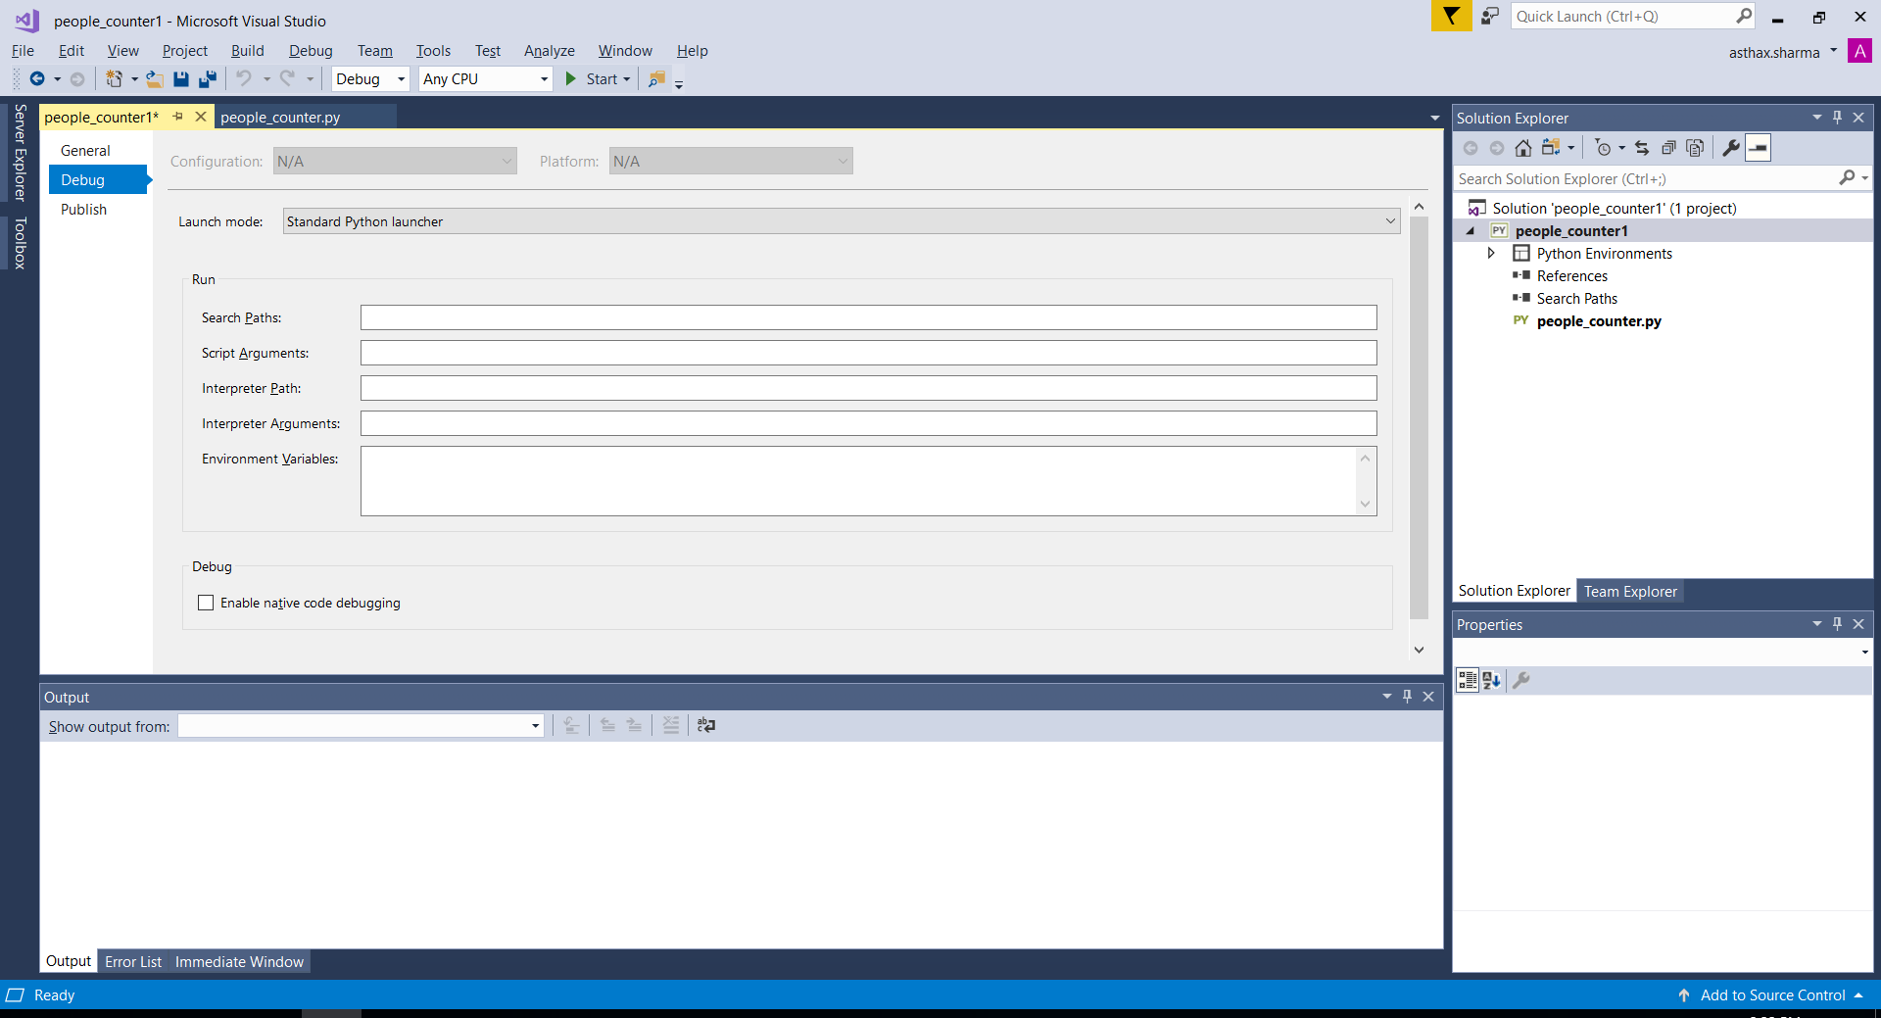

1. Click the text box to the right of ‘Script Arguments’ and enter the following arguments

*-m C:\Intel\AI_on_PC\python_tutorials\Tutorial1_PeopleCounter\model_files\person-detection-retail-0013\FP16\person-detection-retail-0013.xml -i C:\Intel\AI_on_PC\python_tutorials\Tutorial1_PeopleCounter\model_files\Pedestrain_Detection.mp4 -d MYRIAD*

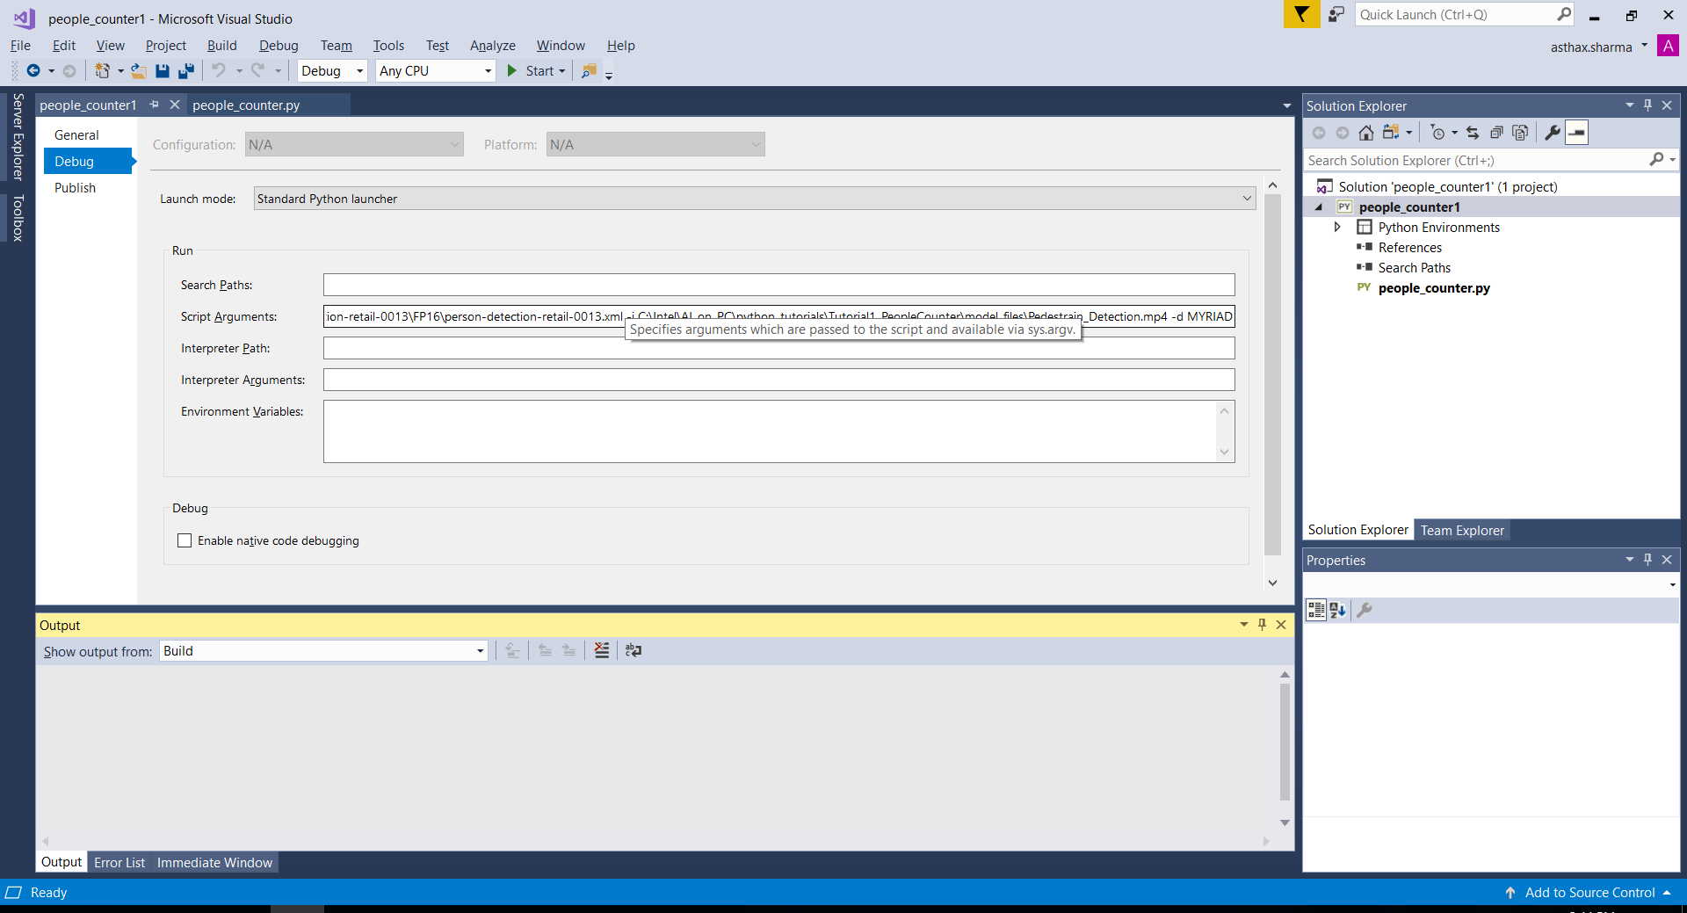

1. Press Ctrl + F5 from the keyboard to run the executable with the arguments provided
2. You will be able to see the progress in the command prompt and the result in a streaming video frame

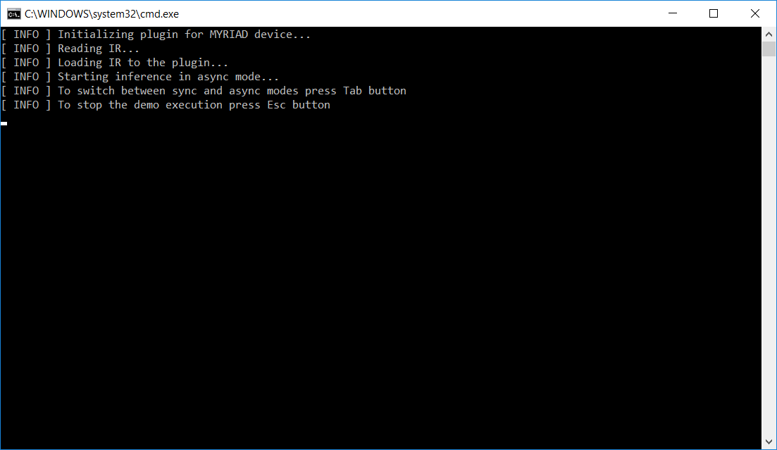



1. Press “Esc” to exit

## **Requirements**

### [Intel® Movidius™ Myriad™ X VPU](https://www.movidius.com/myriadx)

## **Software**

### [Windows](http://releases.ubuntu.com/16.04/) 10

### OpenVINO™